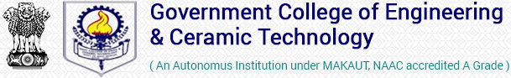

Image Editing with Photoshop
OFFERED BY DEPARTMENT OF INFORMATION TECHNOLOGY, GCECT

WELCOME

We welcome all the eligible participants in our course. The institute will provide a certificate to each participant after successful completion of the course through proper assessment. This course will help everyone to develop confidence to establish a small business in the locality. Throughout the process the COVID-19 appropriate protocols will be maintained strictly.

Objectives:
The objectives are to impart quality training that will help the youth to improve their technical skills and employability.
After completion of this course
1. Students will be able to equip themselves with the operations required in the Photo Color Lab and Printing Job.
2. Students will be able to setup a small business locally with minimal requirement.

COURSE ELIGIBILITY
Minimum academic qualification: Completed 10th Standard

IMPORTANT DATES
Application Forms will be available from 26th December, 2021 to 15th January, 2022
Last date of application form submission: 15th January, 2022
List of Display of shortlisted candidates: 24th January, 2022
Registration and Submission of Course Fees of shortlisted candidates: 25th January, 2022 to 31st January, 2022

COURSE INFORMATION
Batch Size – Maximum 20
Course Start Date: 4th Feb, 2022
Course Duration: 12 weeks
Number of Classes (Theory and Lab) = 60 Hrs (Theory- 20 Hrs and Lab – 40 Hrs)
Classes will be continued for 10 weeks (6 Hrs per week)
Weekly 2 classes (1 class = 3 Hrs) on Friday and Saturday.
Project Work and assessment = 2 weeks
Course Fees = Rs.1000 per participant
(Download the application form here and submit the same after filling it up to the contact person given herewith)

